**Ideation Phase**

**Define the Problem Statements**

|  |  |
| --- | --- |
| Date | 27 September 2022 |
| Team ID | PNT2022TMID13514 |
| Project Name | Gas Leakage Monitoring and Alerting System for Industries |
| Maximum Marks | 2 Marks |

**Customer Problem Statement Template:**

Create a problem statement to understand your customer's point of view. The Customer Problem Statement template helps you focus on what matters to create experiences people will love.

A well-articulated customer problem statement allows you and your team to find the ideal solution for the challenges your customers face. Throughout the process, you’ll also be able to empathize with your customers, which helps you better understand how they perceive your product or service.

Reference: https://miro.com/app/board/uXjVPSrlrFg=/#tpicker-content

**Example:**

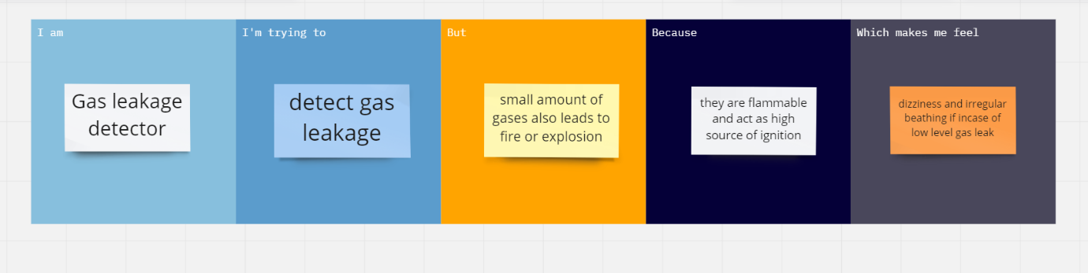

|  |  |  |  |  |  |
| --- | --- | --- | --- | --- | --- |
| **Problem Statement (PS)** | **I am** | **I’m trying to** | **But** | **Because,** | **Which makes me feel** |
| PS-1 | **gas leakage detector** | **detect gas leakage** | **small amount of gases also leads to fire or explosion** | **they are flammable and act as high source of ignition** | **Dizziness and irregular breathing if incase of low level gas leak** |
| PS-2 |  |  |  |  |  |